**Name:** Zeinab Ahmed Younes Ahmed

**B.N:** 374

**Date:**

**Topic:** Artificial Intelligence

**Github link:** <https://github.com/zainabyounes/Artificial-Intelligence>

**Github page:** <https://zainabyounes.github.io/Artificial-Intelligence/>

**Application brief:**

Artificial Intelligence is a subject of Computer Science aimed at building machines and computers that can enhance logical operations. AI systems have the ability to execute tasks naturally associated with human intelligence, like speech recognition, decision-making, visual perception, and translating languages.

Applications of Artificial intelligence:

* Marketing
* Banking
* Finance
* Agriculture
* Health Care
* Gaming
* Space Exploration

**Screenshots:**

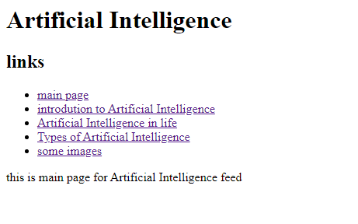

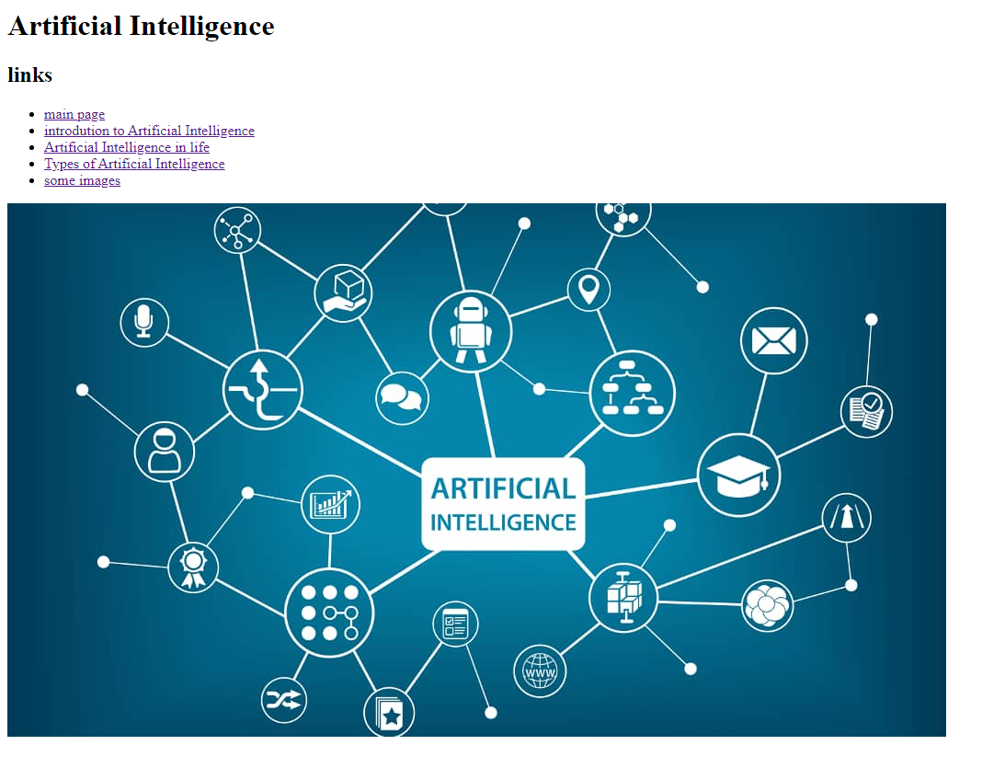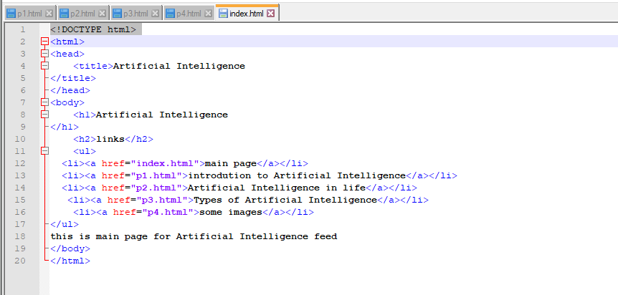**Source code:**